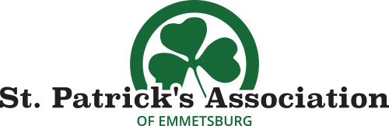
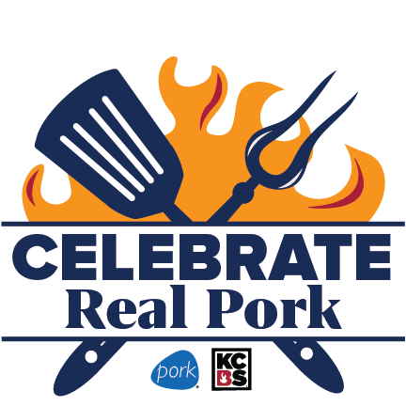

Pork Chop Ancillary
Presented by: National Pork Board & KCBS
Friday, July 30, 2021
www.halfwaytostpats.com

Contact Person/Head Cook*____________________________________
Team/Vendor Name*________________________________
Mailing Address*___________________________ City*_________ State_____ Zip_____
Email*______________________________ Phone*_________________
-Cooks will provide their own meat and shall be subject to meat inspection
Return form and entry fee to: For more information:
St. Pat’s Association Stephanie- 712-480-0252
ATTN: Kids ‘Que E-mail-stpats@iowatelecom.net
1001 Broadway View Website: www.halfwaytostpats.com
Emmetsburg, IA 50536
Please email stephamehan@gmail.com to receive a copy of the official rules.
WAVIER OF LIABILITY: (must be signed to enter)
Emmetsburg St. Pat’s Association, KCBS, including its officers, sponsors, and/or associates and the contestants, and/or legal representatives, agree that the St. Pat’s Association, KCBS, will in no case be responsible for any loss, damage, or injury regardless of how much loss, damage, or injury is occasioned, and indemnify and save harmless The Emmetsburg St. Pat’s Association, KCBS from any and all claims, suits, and/or Judgements including the cost for defense of and such claim and/or by the St. Pat’s Association, KCBS brought by anyone as a result of loss, damage, or injury to any person or property, occasioned by any action or inaction of contestant, either solely or in conjunction with the Emmetsburg St. Pat’s Association or KCBS. Further, I hereby grant full permission to the Emmetsburg St. Pat’s Association, KCBS and/or agents authorized by them, to use any photographs, videotapes, motion pictures, recordings or any other record of the event for any legitimate purpose. I have read and agree to abide by the rules governing the BBQ Cook- off.
Signature: ____________________________________ Date: _____________________
Printed Name: ___________________________________________________________

